Практическое задания функции

Задание 1

def upper(a):

r = ' '

for i in a:

if i.isupper():

r += i

print(r)

upper('PriVet')

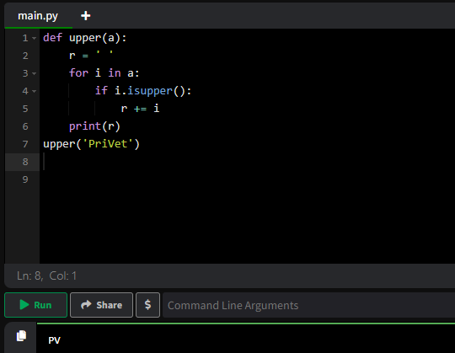

Задание 2

def punct(txt):

c = 0

a = ',.?!()'

for i in txt:

if i in a:

c += 1

print(c)

punct('(Как дела?)')

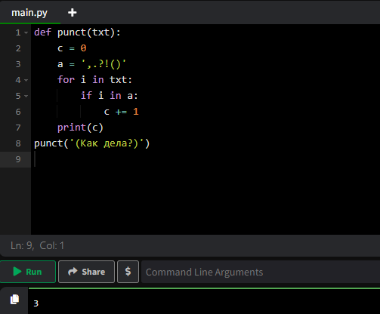

Задание 3

def creaty_cube(x,y):

for i in range(y):

print('*'*x)

creaty_cube(5, 3)

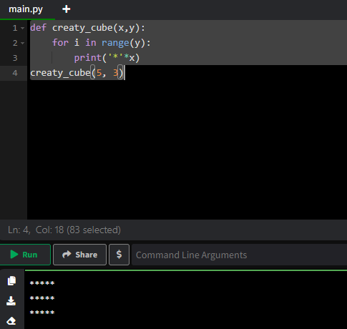

Задание 4

def double(t):

r = ''

for i in t:

r += i * 2

print(r)

double('строка')

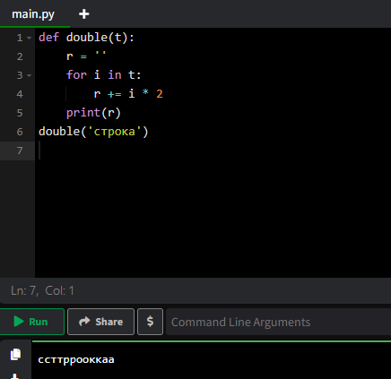

задание 5

def constructor(d, f, c, t):

s = min(d//72,f//4,c//2,t//7)

return s

print(constructor(144,8,4,14))

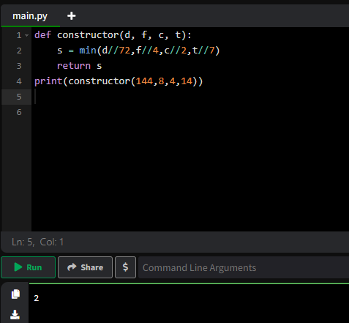

Задание 6

*def* create_list(length, number=0):

*return* [number] * length

print (create_list(5,3))

print(create_list (7))

задание 7

def customFilter(x:list):  
 sum = 0  
 for i in x:  
 if isinstance(i,int):  
 if i % 7 == 0:  
 sum += i  
 print(sum > 83)  
def plainJane(x:int,y:int):  
 print("_"*y)  
 for i in range(x):  
 a = 1  
 for j in range(y):  
 print(f"|{a}|", end=" ")  
 a += 1  
 print()  
 print("-"*y)